**F.4 Biology Ch.11 Transpiration, transport and support in plants: Summary on Practicals**

1. **Demonstration of the occurrence of transpiration (ref: P.3 Practical 11.1)**



**Results and discussion:**

1. Liquid droplets condensed on the inner wall of the bell jar A.

The liquid droplets are water since it turned dry cobalt chloride paper from blue to pink.

This indicates that the plant loses water in form of water vapour by transpiration. The water vapour condenses to water on the wall of bell jar.

1. The plants need to be well-watered before carrying out the experiment to ensure that the plants have obtained enough water for transpiration.
2. The pot and the lower part of the plant should be covered with a transparent polythene bag in order to prevent the water evaporated from soil and the water released during the activities of microorganisms in soil from affecting the results of the experiment.
3. **Measurement of the rate of transpiration using a bubble photometer (ref. P.5 Practical 11.2)**

**Principle:**

A bubble potometer is an apparatus used to measure the rate of water uptake by a cut shoot or young seedlings, by measuring the rate at which an air bubble moves along a capillary tube. Actually, it does not measure the transpiration rate directly, but since most of the water taken up is lost by **_transpiration**____, with the assumption that rate of **__water uptake__** equals to the rate of **__water loss_________**, the rate of movement of the air bubble can be used to represent the approximate transpiration rate of the plant.

Transpiration from the plant surface is mainly due to two physical processes, **_evaporation**__ofwater and **_diffusion**_ of water vapour, therefore any change in the environment affecting the rates of these two processes will also affect the rate of **_transpiration_**. In addition, transpiration mainly takes place through stomata, the **_size__** of stomata, which is in term affected by the **environmental conditions** will also affect the transpiration rate. Therefore the transpiration rates of a leafy shoot under different environmental conditions can be measured and compared using a bubble potometer.



**Result:**

|  |  |  |
| --- | --- | --- |
|  | Non windy condition | Windy condition |
| Initial reading of the potometer (cm) | 0.2 | 6.5 |
| Final reading of the potometer (cm) | 1.4 | 12.2 |
| Time taken to carry out transpiration (min) | 5 | 5 |
| **Rate of transpiration in terms of rate of bubble movement**  **(cm/min)** | **0.24** | **1.14** |

**Discussion**

1. Explain the movement of air bubble in the capillary tube.

As water is lost from the leaves, a pulling force known as **_transpiration pull** is set up. This force draws water up the **_xylem_**vessels of the stem, inducing water absorption. When water is absorbed by the leafy shoot, the air bubble is moved **_towards___** the plant.

(ii) State three necessary ***precautions*** in setting up the potometer.

* The leafy shoot should be cut and fitted into the potometer under **_water___**

to prevent air from entering the **__xylem__**vessels and block the upward movement of water.

- All junctions should be air tight or sealed with vaseline to prevent **_leakage__**.

- The bubble introduced should be **_small__** to prevent movement of it being slowed down / breakage of the continuous water column.

(iii) It is not necessary to add a layer of oil on the surface of water inside the reservoir because the water in the reservoir is used to refill the **_capillary tube__** and move the **__bubble____** to the starting point. Any **_water _evaporation__** does not affect the movement of the air bubble.

1. The leafy shoot has a **higher** transpiration rate after it is blown by a hair dryer because wind blows away the water vapour from the leaf surfaces rapidly. This maintains a steep concentration gradient of water vapour between the air spaces inside the leaf and the surrounding air. Therefore water vapour in the leaf diffuses out more rapidly.
2. State four environmental factors that may affect the rate of transpiration of a plant.

|  |
| --- |
| **Light intensity, humidity, wind speed, temperature** |

1. **Measurement of the rate of transpiration using a weight photometer (ref. P.6 Practical 11.3)**

**Principle:**

A weight potometer is an apparatus used to measure the rate of transpiration of a cut shoot or young seedlings. The volume of water loss from the plant can be obtained by measuring the change in **_weight_____** of the whole set-up. The rate of transpiration can then be measured by calculating the **__volume____** of water loss per unit time.

In this investigation, the volume of water absorbed by the plant can also be found by measuring the change in water level in the burette of the set-up. The rate of water loss and rate of transpiration can then be compared.

**Procedure:**

1. Cut a leafy shoot from a plant under water and fitted the shoot into the weight photometer

under water as shown in the following diagram.

1. Put a layer of oil on the water surface in the burette.
2. Note down the initial water level in the burette and the weight of the whole apparatus.
3. After **1 hour**, record the water level and the weight of the whole apparatus again

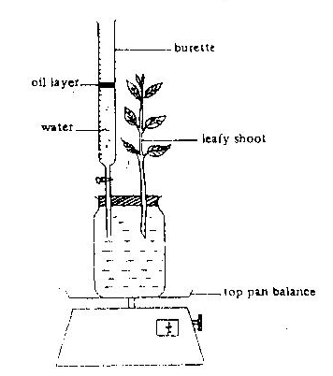

burette

Leafy shoot

Top pan balance

Oil layer

water

***Precautions:***

- Make sure that the leafy shoot and the wall

of the apparatus are **_dry__**.

- Cut the leafy shoot under **__water____**

- Fit the leafy shoot into the weight potometer under

**water**

- All junctions should be air tight or sealed

with **___vaseline** to prevent water leakage.

***[refer to the precautions for the bubble photometer for the reason behind each precaution]***

1. **Results**

A table showing the water level in the burette and weight of the set-up before and after the experiment

|  |  |  |
| --- | --- | --- |
|  | Water level in the burette (cm3) | Weight of the whole set-up (g) |
| At the start | V1 | W1 |
| After the experiment | V2 | W2 |

Rate of water uptake = (V1 – V2)/time [unit: cm3/h]

Rate of transpiration = (W1 – W2)/time [unit: g/h]

1. **Discussion**

(i) Compare the volume of water loss and water uptake of the leafy shoot. Give an explanation for such difference.

The volume of water uptake is slightly greater than the volume of water loss.

This is because not all water absorbed by a plant is transpired or lost. A certain amount of water is retained by the plant for **__photosynthesis______** and plant growth etc.

(ii) Why is it necessary to add a layer of oil on the water surface in the burette?

To prevent **_water evaporation__**from the burette which may affect the measurement of the amount of water **_uptake__________**and water **___loss_________** through transpiration.

(iii) Compare the use of weight potometer and the bubble potometer to measure the rate of transpiration, which method is better? Explain your answer.

The **_weight_________**potometer is more accurate.

Because __**weight**_______ potometer can measure the transpiration rate of a leafy shoot directly, but the ___**bubble**______ potometer can only measure **__rate of water uptake__**_of the leafy shoot.

1. **Study the stomatal distribution on the upper and lower surfaces of a leaf**

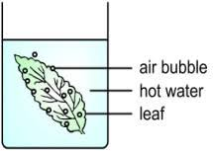**Procedure:**

A piece of *Hibiscus* leaf was immersed into hot water.

**Observation /result:**

More bubbles appear on the lower surface of the leaf than that of the upper surface.

**Explanation:**

Gas in the intercellular air space expands upon heating and is forced out through the stomata. More gas bubbles appear on the lower surface than on the upper surface. This implies that the lower surface contains more stomata.

1. **Study the distribution plant tissues for water transport (ref. P.11 Practical 11.7)**

**Procedure**

1. Immerse the stem of Chinese flowering cabbage and petiole of celery plant in dilute eosin solution for 1 day.
2. Cut thin transverse sections of the stem of Chinese flowering cabbage and petiole of celery plant.
3. Examine the sections with a light microscope and identify the parts that are stained red.

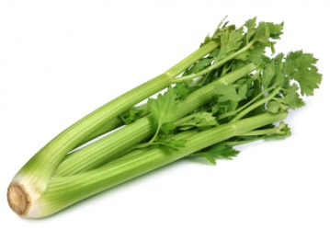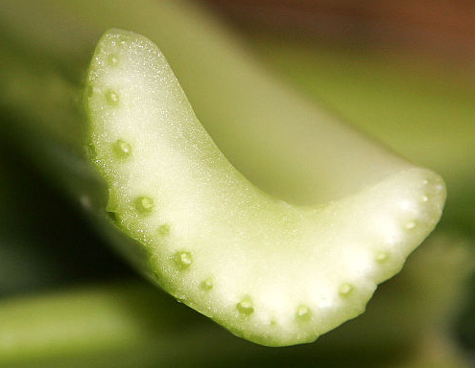

Celery plant

**Results**

|  |  |
| --- | --- |
| **Transverse section of stem of Chinese flowering cabbage** | **Transverse section of petiole of celery plant** |

Xylem is stained red in stem and petiole sections. This shows that xylem is responsible for the transport of water in the plants.